

**UNIVERSITY OF THE EAST – CALOOCAN**

**COLLEGE OF ENGINEERING**

**Computer Engineering Department**

**MACHINE PROBLEM #3**

***“FUNCTIONS”***

**NCP 1203 – Data Structures and Algorithms**

**1CP**

**Submitted To:**

**DR. JOAN P. LAZARO**

**CpE Professor**

**Submitted By:**

**DANIOT, GABRIEL F.**

**1/8/2020**

1. Write a program in C++ using function that asks the user to enter an item’s wholesale cost and its markup percentage. It should then display the item’s retail price.

For example:

If an item’s wholesale cost is 5.00 and its markup percentage is 100 percent, then the item’s retail price is 10.00. If an item’s wholesale cost is 5.00 and its markup percentage is 50 percent, then the Item’s retail price is 7.50.

|  |  |
| --- | --- |
| #include<iostream>  using namespace std;  float retail(float wc, float mp);  main()  {  int x,y;  float rp;  cout << "Enter wholesale cost: ";  cin >> x; cout << "Enter mark up percentage: ";  cin >> y; | rp=retail(x,y);  cout << "The retail price is: " << rp << endl;  system("pause");  }  float retail(float wc,float mp)  {  float x,y,rp;  rp=wc+(wc*mp/100);  return rp;} |

|  |  |
| --- | --- |
| #include<iostream>  using namespace std;  float Average(float x,float y);  float SumSQ(float x, float y);  float SumQS(float x, float y);  main()  {  int a,b;  float A,SSQ,SQS;  cout << "Enter the 1st number: ";  cin >> a;  cout << "Enter the 2nd number: ";  cin >> b;  A=Average(a,b);  SSQ=SumSQ(a,b);  SQS=SumQS(a,b);  cout << "\nthe sum of squares is " << SSQ << endl;  cout << "the average is " << A << endl;  cout << "the square of sum is " << SQS << endl;  system("pause");  } | float Average(float x, float y)  {  float a,b,A;  A=(x+y)/2;  return A;  }  float SumSQ(float x, float y)  {  float a,b,SSQ;  SSQ=x*x+y*y;  return SSQ;  }  float SumQS(float x, float y)  {  float a,b,sq,SQS;  SQS=(x+y)*(x+y);  return SQS;  } |

2. Create a C++ program that will compute the Average, Sum of the squares, and Square of the sums of two numbers using Functions.

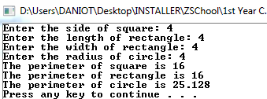3. Create a C++ program that will compute the perimeter of square, rectangle, and circle using functions.

|  |  |
| --- | --- |
| #include<iostream>  using namespace std;  float Square(float s);  float Rectangle(float l, float w);  float Circle(float r);  main()  {  float a,b,c,d,PS,PR,PC;  cout << "Enter the side of square: ";  cin >> a;  cout << "Enter the length of rectangle: ";  cin >> b;  cout << "Enter the width of rectangle: ";  cin >> c;  cout << "Enter the radius of circle: ";  cin >> d;  PS=Square(a);  PR=Rectangle(b,c);  PC=Circle(d);  cout << "The perimeter of square is " << PS<< endl;  cout << "The perimeter of rectangle is " << PR << endl; | cout << "The perimeter of circle is " << PC << endl;  system("pause");  }  float Square(float s)  {  float a,PS;  PS=4*s;  return PS;  }  float Rectangle(float l, float w)  {  float a,b,PR;  PR=2*l+2*w;  return PR;  }  float Circle(float r)  {  float a,PC;  PC=2*3.141*r;  return PC; |

4. A prime number is a number that is evenly divisible only by itself and 1. For example, the number 5 is prime because it can be evenly divided only by 1 and 5. The number 6, however, is not prime because it can be divided evenly by 1, 2, 3, and 6. Write a C++ program using function which takes an integer as an argument and returns true if the argument is a prime number, or false otherwise. Demonstrate the function in a complete C++ program.

|  |  |
| --- | --- |
| #include<iostream>  using namespace std;  int prime(int x, int y);  main()  {  int a, b=2,ctr;  cout << "Enter a number: ";  cin >> a;  prime(a,b);  system("pause");  }  int prime(int x,int y) { | int a,b;  for(y=2; y<x; y++)  {  if(x%y==0 && x>1)  {  cout << "NOT" << endl;  break;  }  else  {  cout << "PRIME" << endl;  break;}}} |

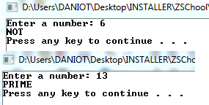

5. A painting company has determined that for every 115 square feet of wall space, one gallon of paint and eight hours of labor will be required. The company charges P120.00 per hour for labor. Write a program that allows the user to enter the number of rooms to be painted and the price of the paint per gallon. It should also ask for the square feet of wall space in each room. The program should have functions that return the following data:

|  |  |
| --- | --- |
| #include<iostream>  using namespace std;  float gall(float, float);  float hrs (float, float);  float paint (float, float, float);  float lab (float, float);  float cost (float, float, float);  int main()  {  float a, b, c, g, h, cst, ch, ttl;  cout<< "Enter the Number of Rooms: ";  cin>> a;  cout<< "Enter Price of the Paint per Gallon: ";  cin>> b;  cout<< "Enter the Square Feet of Wall Space in Each Room: ";  cin>> c;  g=gall(a,c);  h=hrs(a,c);  cst=paint(a,b,c);  ch=lab(a,c);  ttl=cost(a,b,c);  cout<< "\nThe Number of Gallons of Paint needed is " << g << endl;  cout<< "\nThe Hours of Labor Required is " << h << endl; | cout<< "\nThe Cost of the Paint is " << cst << endl;  cout<< "\nThe Labor Charges is " << ch << endl;  cout<< "\nThe Total Cost of the Paint Job is " << ttl << endl;  system ("pause");  }  float gall (float a, float c)  {  float w; w=(c/115)*a; return (w);  }  float hrs (float a, float c)  { float x; x=((c/115)*a)*8; return (x); }  float paint (float a, float b, float c)  {  float y; y=((c/115)*a)*b; return (y); }  float lab (float a, float c)  {  float z;  z=(((c/115)*a)*8)*120.00;  return (z); }  float cost (float a, float b, float c)  { float l;  l=((((c/115)*a)*8)*120.00)+(((c/115)*a)*b); return (l);  } |

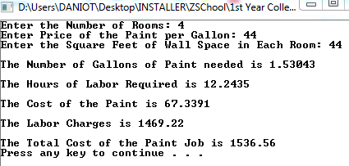

6. Write a program that asks the user to enter a distance in meters. The program will then present the following menu of selections:

|  |  |
| --- | --- |
| #include<iostream>  #include<iomanip>  using namespace std;  float showMenu();  float showKilometers (float a);  float showInches (float a);  float showFeet (float a);  int main()  {  float x;  int choice;  cout<< "Enter a distance in meters: ";  cin>> x;  if (x < 0)  {  cout<< "Invalid!" <<endl;  system("pause");  }  do  {  showMenu();  cout<< "\nEnter Choice: ";  cin>> choice;  if (choice==1)  {  showKilometers(x);  }  else if (choice==2)  {  showInches(x);  }  else if (choice==3) {  showFeet(x); | }  else if (choice==4)  {  cout<< "Bye!" <<endl;  }  else  {  cout<< "Error!" <<endl;  }  }while(choice!=4);  system("pause");  }  float showMenu()  {  cout<< "\n1. Convert to kilometers" <<endl;  cout<< "2. Convert to inches" <<endl;  cout<< "3. Convert to feet" <<endl;  cout<< "4. Quit the program" <<endl;  }  float showKilometers(float a)  {  cout<< a << " meters is now converted to " << a*0.001 << " kilometers";  }  float showInches(float a)  {  cout<< a << " meters is now converted to " << a*39.37 << " inches";  }  float showFeet(float a)  {  cout<< a << " meters is now converted to " << a*3.281 << " feet";  } |

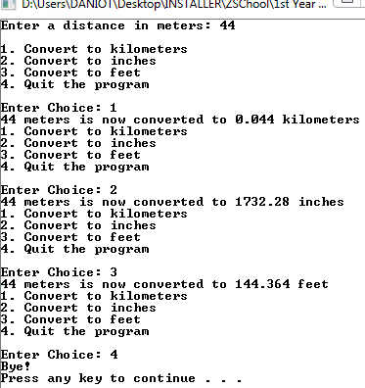

**REFLECTION:**

For me this particular c program just makes the code more complex and technical because it just divides the codes into two separated code. However, on a larger scale of codes it can become easier to use specially when repeating a program. Furthermore, this function really helped me understand to code much more and I also like to learn a more technical code as it increase my analytic thinking I hope that a can understand more in the function statements because there are still things that I don’t know.